# Ex1: Preparation of BioData using libreoffice -writer

# BIO-DATA

NAME : VIKRAM KUMAR JHA

FATHER’s NAME : PAWAN KISHOR JHA

(ACCOUNTANT)

BIHAR STATE ELECTRICITY BOARD

D.O.B : 25|10|1987

SEX : MALE

BLOOD GROUP : B +ve

RELIGION : HINDU

NATIONALITY : INDIAN

ADDRESS : 13|6 MANIMEGALAI STREET

RAJAJI NAGAR

PALLAVARAM

CHENNAI – 43

EDUCATIONAL

QUALIFICATION :

|  |  |  |  |  |
| --- | --- | --- | --- | --- |
| COURSE | INSTITUTE | UNIVERCITY | YEAR | % |
| 10th | L.M.HIGH SCHOOL | B.S.E.B | 2002 | 70% |
| 12th | C.M.SCIENCE COLLEGE | B.I.E.C | 2004 | 55% |
| BCA | TAGORE COLLEGE OF ARTS & SC. | MADRAS  UNIVERSITY | 2006-2009 | DOING |

# EXTRA ACTIVITY : BADMINTON, CHESS, COOKING

DATE : 07.1.2014 SIGNATURE:-

PLACE:

**Ex2: Bullets andNumbering abd Header and Footer usage in libreoffice -writer**

# WIPRO

**15, Nelson Manickam Road,**

**Chennai-600 029.**

   _________________________________________________________________________

# TO

Miss .K.Anu,

12, M.G.R Street,

Ambattur,

Chennai-600 067,

Respected Madam,

Subject: Application for the post of SOFTWARE PROGRAMMER

                               With the reference to your application dated on the 21st of

July we are favourably impressed by your qualification. You can appear for-

The interview on the 4th of October any time.

* The office will be functioning from 9.00am-5.00pm
* Bring your original certificates at the time of interview.
  1. You will be having technical round
  2. Group discussion
  3. Aptitude test
  4. HR round

     HCL INFOSYSTEM

        (General Manager)

**Phone: 2374 2420**

**E-mail: Hclinfosystem@hotmail.com**

**EX3: Pay slip preparation using liber office -calc**

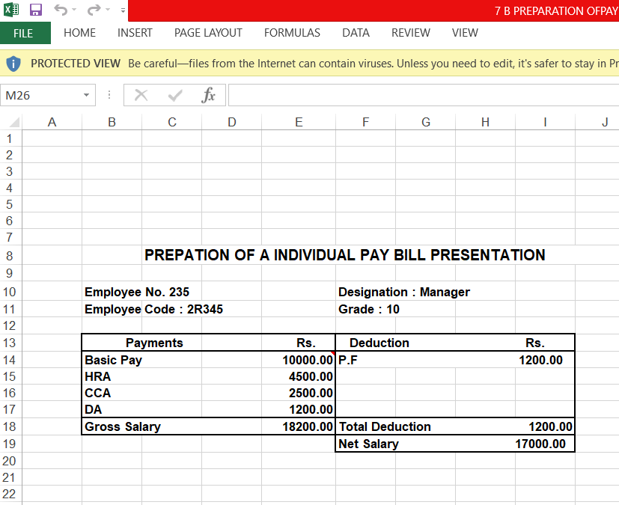

**Ex4:Student mark statement preparation using libre office -calc**



**Ex5:PRESENTATION TO PROMOTE A**

**PRODUCT using kibreoffice -impress**

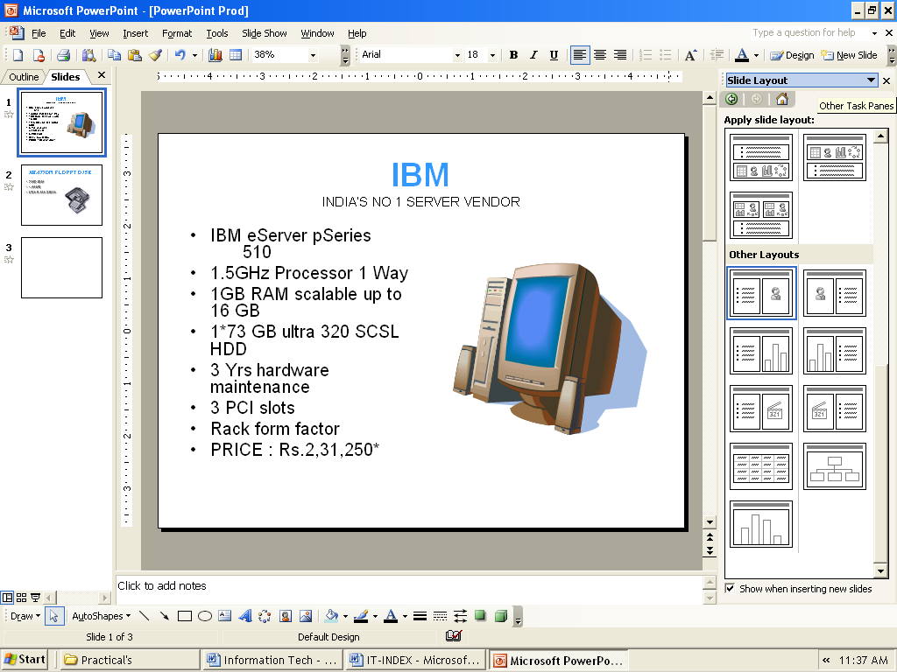

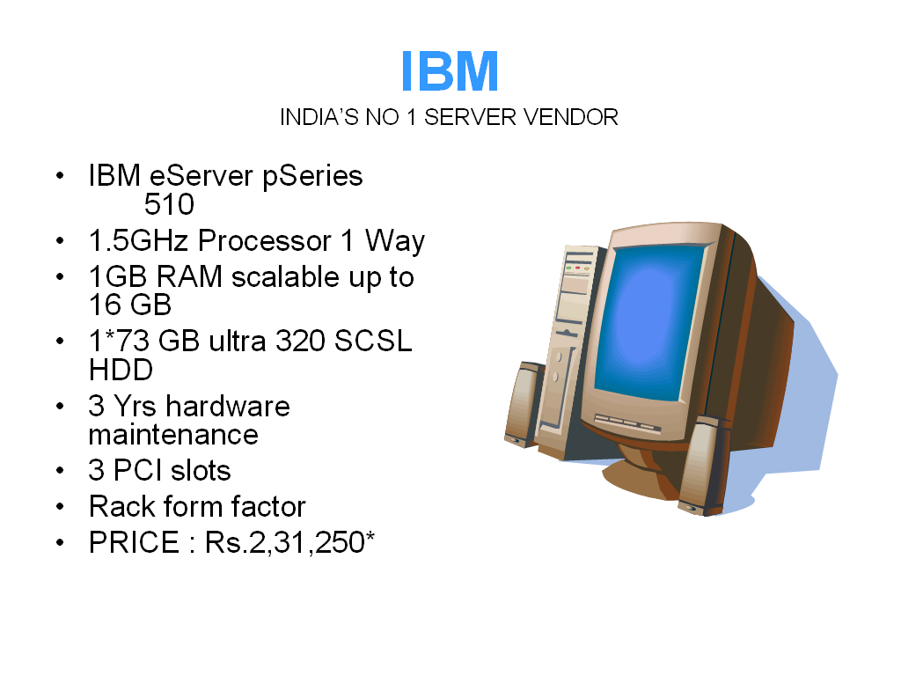

Ex6: ID card preparation using impress

Ex7: Students Registration Form Validation application using PHP

<!DOCTYPE HTML>

<html>

<head>

</head>

<body>

<!DOCTYPE HTML>

<html>

<head>

<style>

.error {color: #FF0000;}

</style>

</head>

<body>

<?php

// define variables and set to empty values

$nameErr = $emailErr = $genderErr = $websiteErr = "";

$name = $email = $gender = $comment = $website = "";

if ($_SERVER["REQUEST_METHOD"] == "POST") {

if (empty($_POST["name"])) {

$nameErr = "Name is required";

} else {

$name = test_input($_POST["name"]);

// check if name only contains letters and whitespace

if (!preg_match("/^[a-zA-Z-' ]*$/",$name)) {

$nameErr = "Only letters and white space allowed";

}

}

if (empty($_POST["email"])) {

$emailErr = "Email is required";

} else {

$email = test_input($_POST["email"]);

// check if e-mail address is well-formed

if (!filter_var($email, FILTER_VALIDATE_EMAIL)) {

$emailErr = "Invalid email format";

}

}

if (empty($_POST["website"])) {

$website = "";

} else {

$website = test_input($_POST["website"]);

// check if URL address syntax is valid (this regular expression also allows dashes in the URL)

if (!preg_match("/\b(?:(?:https?|ftp):\/\/|www\.)[-a-z0-9+&@#\/%?=~_|!:,.;]*[-a-z0-9+&@#\/%=~_|]/i",$website)) {

$websiteErr = "Invalid URL";

}

}

if (empty($_POST["comment"])) {

$comment = "";

} else {

$comment = test_input($_POST["comment"]);

}

if (empty($_POST["gender"])) {

$genderErr = "Gender is required";

} else {

$gender = test_input($_POST["gender"]);

}

}

function test_input($data) {

$data = trim($data);

$data = stripslashes($data);

$data = htmlspecialchars($data);

return $data;

}

?>

<h2>PHP Form Validation Example</h2>

<p><span class="error">* required field</span></p>

<form method="post" action="<?php echo htmlspecialchars($_SERVER["PHP_SELF"]);?>">

Name: <input type="text" name="name" value="<?php echo $name;?>">

<span class="error">* <?php echo $nameErr;?></span>

<br><br>

E-mail: <input type="text" name="email" value="<?php echo $email;?>">

<span class="error">* <?php echo $emailErr;?></span>

<br><br>

Website: <input type="text" name="website" value="<?php echo $website;?>">

<span class="error"><?php echo $websiteErr;?></span>

<br><br>

Comment: <textarea name="comment" rows="2" cols="30"><?php echo $comment;?></textarea>

<br><br>

Gender:

<input type="radio" name="gender" <?php if (isset($gender) && $gender=="female") echo "checked";?> value="female">Female

<input type="radio" name="gender" <?php if (isset($gender) && $gender=="male") echo "checked";?> value="male">Male

<input type="radio" name="gender" <?php if (isset($gender) && $gender=="other") echo "checked";?> value="other">Other

<span class="error">* <?php echo $genderErr;?></span>

<br><br>

<input type="submit" name="submit" value="Submit">

</form>

<?php

echo "<h2>Your Input:</h2>";

echo $name;

echo "<br>";

echo $email;

echo "<br>";

echo $website;

echo "<br>";

echo $comment;

echo "<br>";

echo $gender;

?>

</body>

</html>

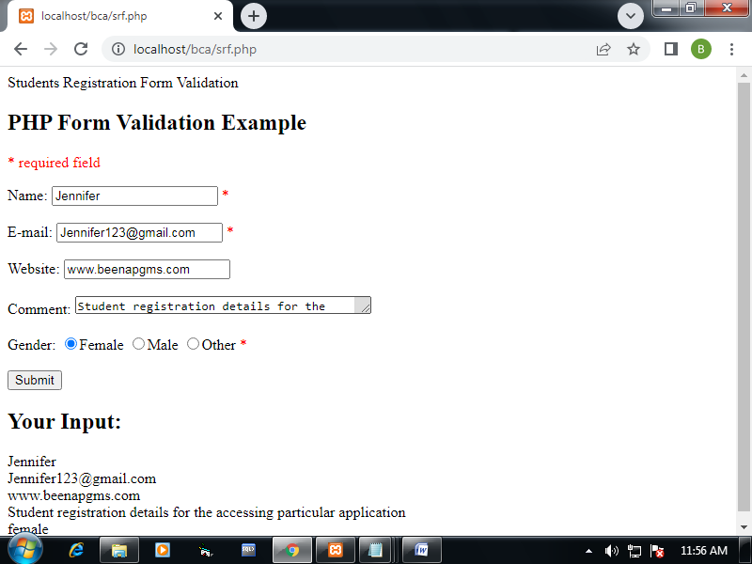

Ex8: Student details maintenance using PHP with MySQL

Database connectivity

<html>

<head>

<title>Creating MySQL Table</title>

</head>

<body>

<?php

$host = 'localhost:3306';

$user = '';

$pass = '';

$dbname = 'test';

$mysqli = new mysqli($host, $user, $pass, $dbname);

if($mysqli->connect_errno ) {

printf("Connect failed: %s<br />", $mysqli->connect_error);

exit();

}

printf('Connected successfully.<br />');

$sql = "SELECT sid, sname FROM stud";

$result = $mysqli->query($sql);

if ($result->num_rows > 0) {

while($row = $result->fetch_assoc()) {

printf("Id: %s, StudentName: %s <br />",

$row["sid"],

$row["sname"]);

}

} else {

printf('No record found.<br />');

}

mysqli_free_result($result);

$mysqli->close();

?>

</body>

</html>

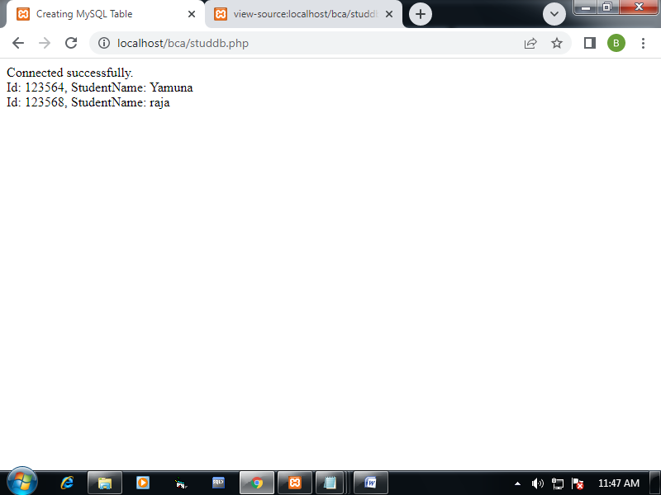

Ex9: Students management system Application using Python

Ex10: Git version control system -Repository creation and open an existing repository to maintain the different version control projects

Commands

$git config –global user.name “Hemalatha”

$git config –global email.name [bcadepttagore@gmail.com](mailto:bcadepttagore@gmail.com)

$git –list

$git init <repository name>

$git init OSTLAB

$git add <filename>

$git add test.txt

$git clone <url>

$git clone https://github.com/kumuthaparthiban/ostlab

$git status

$git push test.txt

$git commit –m “Messages push the file test.txt into the github repository”

$git status stage

$git pull https://github.com/kumuthaparthiban/ostlab

$git commit –m “Messages pull the file test1.txt into the github repository”

$git status stage

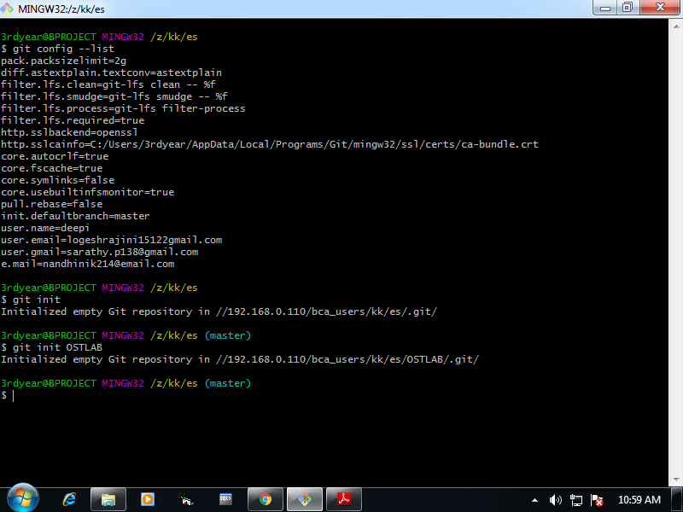

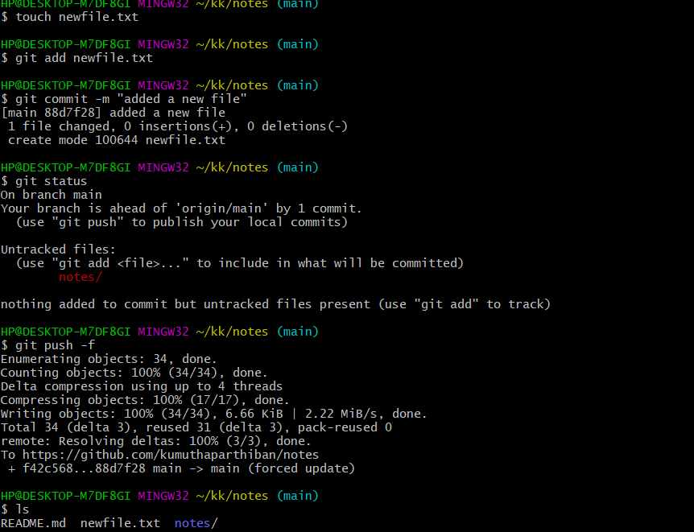

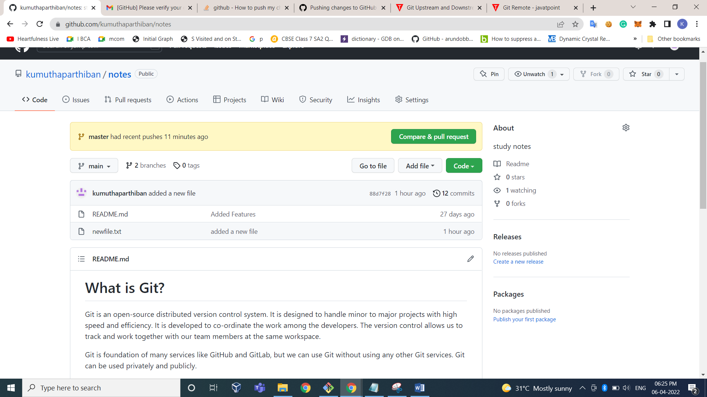

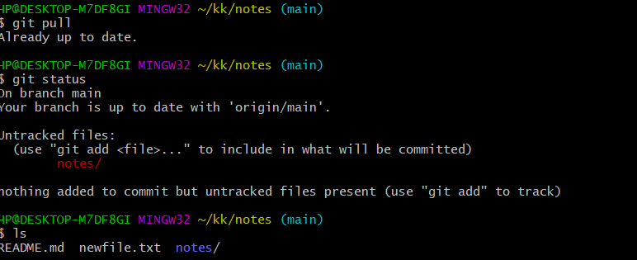

Ex11: Text processing using perl

1. PROGRAM: Text Manuplultion

print "What is your name?\n";

$name = <>;

chomp($name); # removes newline character

print "Your name is ",$name,"\n";

print chr(70),"\n";

print q{(abc@example.com)};

print "\n";

print qq{(abc@example.com)\n};

print "abc"x3,"\n";

$a = "abcdefghij";

print length($a),"\n";

$a = "Hey there World";

print substr($a,4),"\n";

print substr($a,0,3),"\n";

print index("Hey there!Hey","y"),"\n";

print rindex("Hey there!Hey","y"),"\n";

print join("-",(1,2,3)),"\n";

print lc("Hey EveryONE"),"\n";

print ucfirst("hey EveryONE"),"\n";

print uc("hey EveryONE"),"\n";

@a = split(/-/, "1-2-3");

print "@a\n";

1. String Replace.comparison and concatenation

my $var1 = "Tigers are big and frightening.";

$var1 =~ s/Tigers/Lions/;

print "$var1\n";

my $var2 = "Red roses are very popular. Yellow roses are less seen.";

$var2 =~ s/roses/flowers/g;

print "$var2\n";

my $string1 = "Ana";

my $string2 = "Ana";

if($string1 eq $string2) {

print "Match!\n";

}

my $string3 = "Ana";

my $string4 = "Christian";

if($string3 eq $string4) {

print "Match\n!";

}else{

print "Missmatch!\n";

#concatenation program

$a= "Smith";

$b = "Grey";

#$middlename="Reddy";

$fullName = $a . " ".$b;

print "$fullName\n";

Ex12: Logo designing using GIMP

Ex13: Photo editing using GIMP

Ex14: Report designing using BIRT

Ex15: Linux Configuration commands

* Configuration management is a process for maintaining computer systems, servers, and software in a desired, consistent state.
* Most Linux administrators prefer to write scripts for any network settings. So, once a script is written, next time onwards,
* the Administrator just needs to change the permissions of the script using
  + ‘chmod u+x’

* And then execute the shell script in any Linux Network.

1. The best tool for configuring a Linux network is software known as ‘netenv’, meaning ‘network environment’. One can install this tool by typing the following:- SuperUser or just a User

$ sudo apt-get install netenv

1. [Nmap](https://www.educba.com/nmap-commands/) also helps to scan how many systems are connected to the network, which ports are open, what services are being run, what is the operating system, and other stuff. Before I run a [Nmap scan](https://www.educba.com/what-is-nmap/), I need to set up a gateway for my other individual systems, and I can do that with the help of the following command:

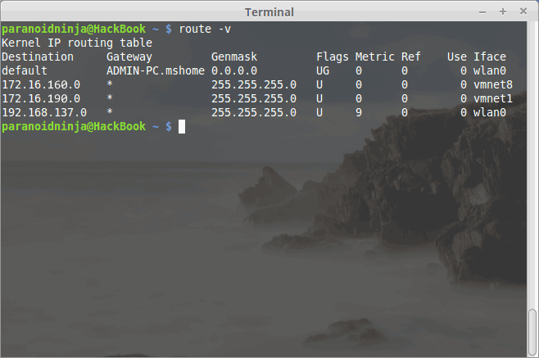

my gateway is 192.168.137.0

1. To get information about the open ports, services, and connected systems with the help of the following command:

$sudo nmap -A -O 192.168.x.x

Important stuff to know while Configuring a Linux Network environment

1. **Telnet**
   1. The Telnet is software used for accessing a computer remotely. [Telnet](https://www.educba.com/what-is-telnet/) is one of the most used software, and it is also very popular, but it is terminal or, more preferably, console-based.
   2. There is, however, an encrypted version that is used instead of the basic telnet known as SSH (Secure Shell), which requires a PGP key to authenticate to the remote host. Similar software is also available for Windows, which is known as putty. Both of these software is interoperable. SSH can be installed via the following command:

***$ sudo apt-get install OpenSSH-server***

|  |
| --- |
|  |

1. **To create a new user account from shell prompt following steps are to be performed:**

* Firstly login as a root user if you are not logged in as root use

$su – command.

* Enter the root password.
* The command to add a new user is useradd command and can be used in Linux. Use this command and then type the username you would like to create.

$ useradd sue

1. To set the password to follow below steps:

* To set a password for user sue type command:

$passwd sue.

* It will prompt the user to enter a new password.
* Once this is done it will also ask the user to retype password thereby setting up the password for the user

1. To get the packet related information of network interface.

$ Ifstat

EX16: Linux Installation procedure

# How to Install Linux on Windows 10

### Linux is a family of open-source operating systems

to dual boot Linux and Windows, you will need to create a space for your Linux OS to live.

## How to Partition a Hard Drive in Windows 10

1. **Open the Windows Search Bar**. This is the magnifying glass-shaped icon in the bottom-left corner of your screen.
2. **Then type “DISKMGMT.MSC” in the search bar and hit enter**.

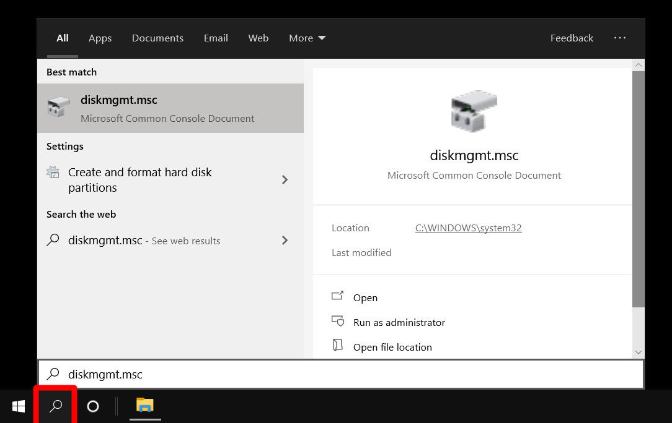

**3.Right-click on your main hard drive and select Shrink Volume**. If you have more than one drive, make sure to choose the one that says Primary Partition. This will usually be labeled as the C: drive.

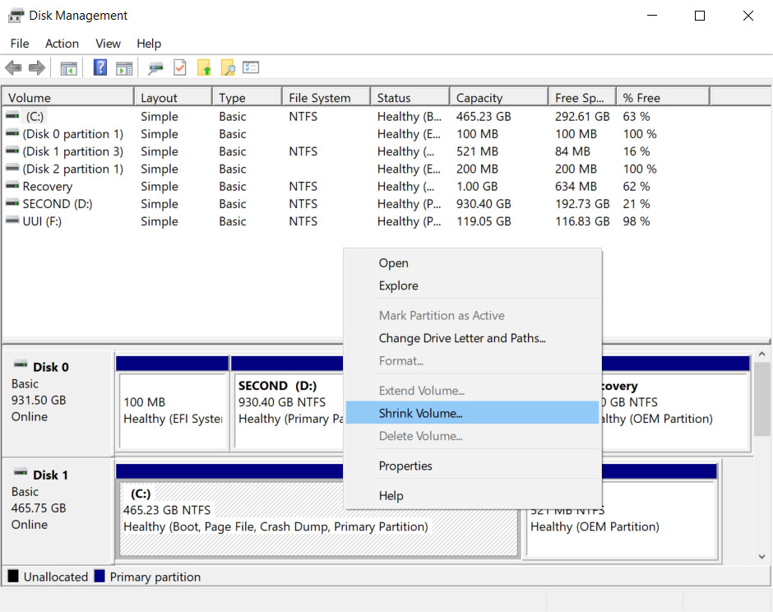

**4.Then choose how much you want to shrink your drive.** It is recommended that you set aside at least 20GB (20,000MB) for Linux.

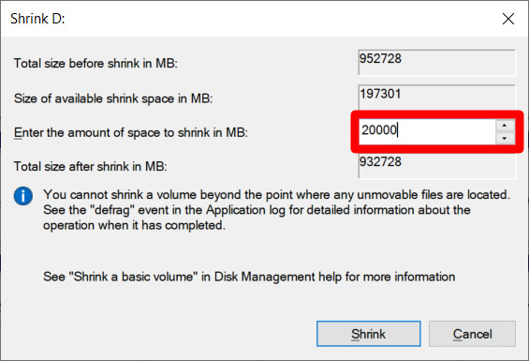

**5.Finally, click Shrink**.

## How to Make a Linux Bootable USB

1. **Download a Linux distro in ISO format.** An ISO file is a disk image. Some of the top options are [Ubuntu](https://ubuntu.com/download/desktop), [Mint](https://linuxmint.com/download.php), or [Fedora](https://getfedora.org/). They are free to download from each distribution’s main website. For this article, we are using Ubuntu.
2. **Insert the USB drive into your computer**. You might be asked to format your drive. This will erase all the data stored on your drive, so make sure to back up your files before you begin.
3. **Download Rufus**. You can find the latest version of the application [here](https://rufus.ie/).
4. **Open Rufus and select your USB drive from the Device list**. If you don’t know which drive to use, eject all other drives until you only have one to choose from.
5. **Under Boot Selection, click the Select button and choose the ISO file you downloaded earlier.**Don’t change the other default settings.

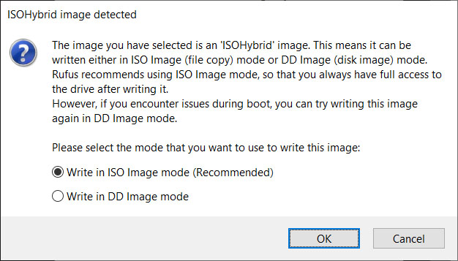

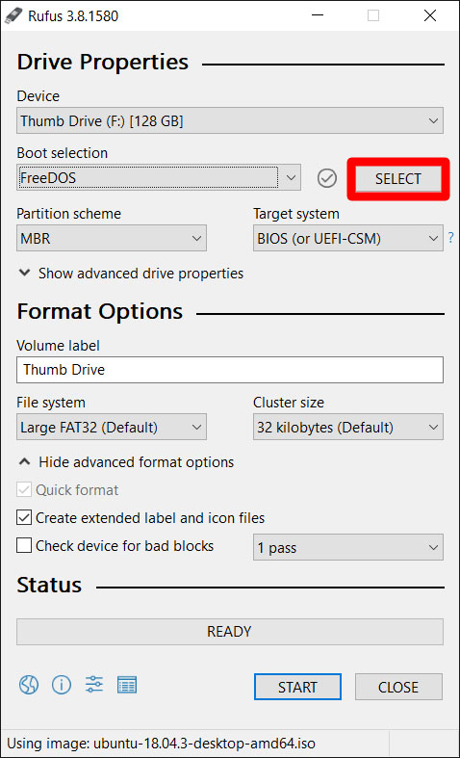

1. **Finally, click Start**. If you get a pop-up message asking you to select a mode that you want to use to write the image, choose ISO.

## How to Install Linux from USB

Now that you have your Linux distro on a USB, here’s how to

1. **Insert a bootable Linux USB drive**.
2. **Click the start menu**. This is the button in the lower-left corner of your screen that looks like the Windows logo.
3. **Then hold down the SHIFT key while clicking Restart**. This will take you into the Windows Recovery Environment.

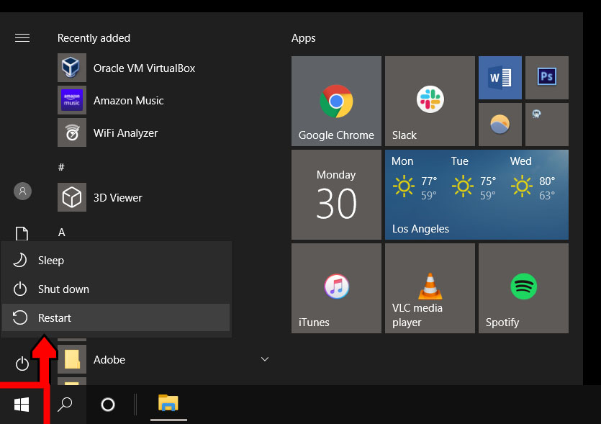

1. **Then select Use a Device**.

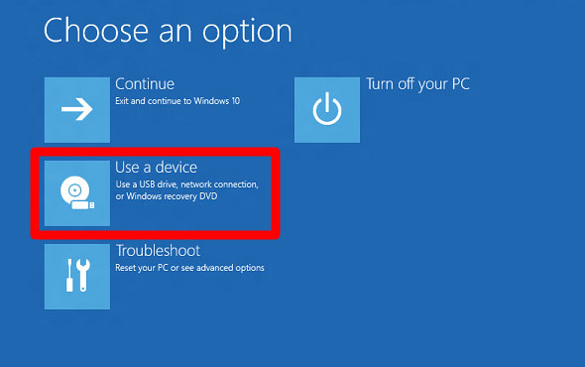

1. **Find your device in the list**. If you don’t see your drive, choose EFI USB Device, then pick your drive from the next screen.

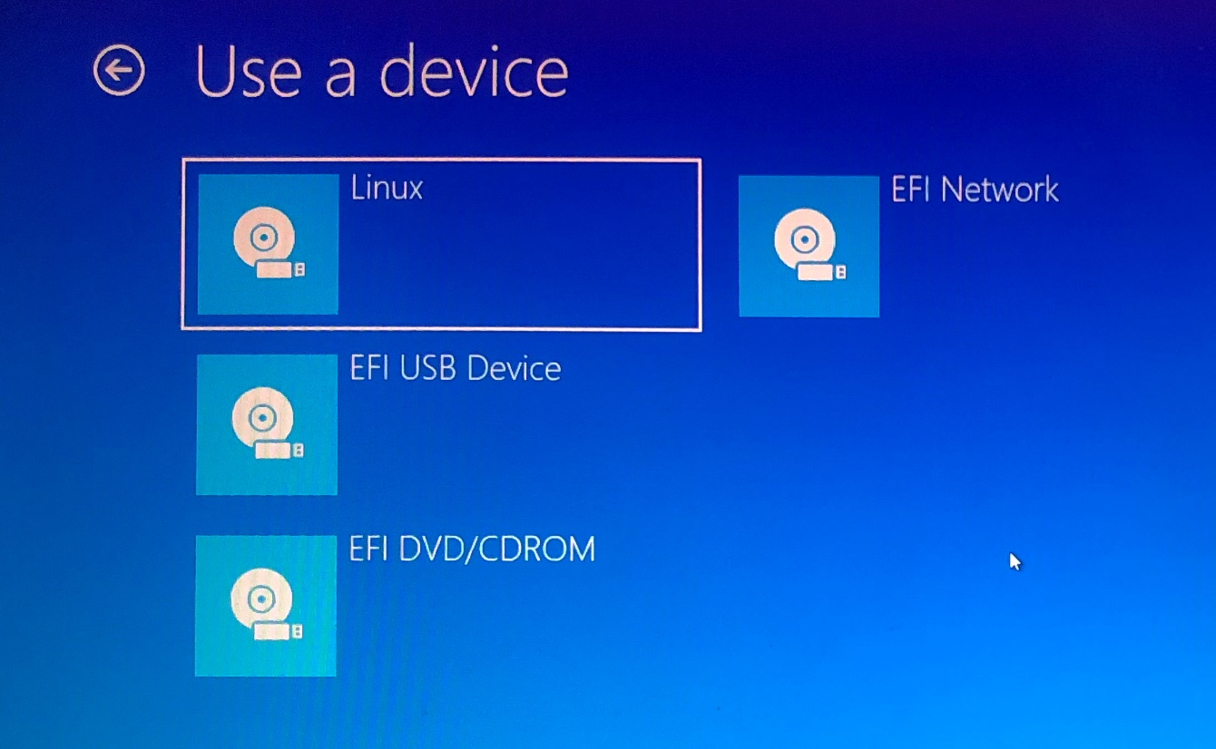

1. **Your computer will now boot Linux**. If your computer reboots Windows, there was either an issue with your drive, or you might have to change settings in your BIOS.

Warning: Changing BIOS settings can damage your computer if you don’t know what you’re doing.

1. Select Install Linux. Some distros also let you try out the OS before installing it here.

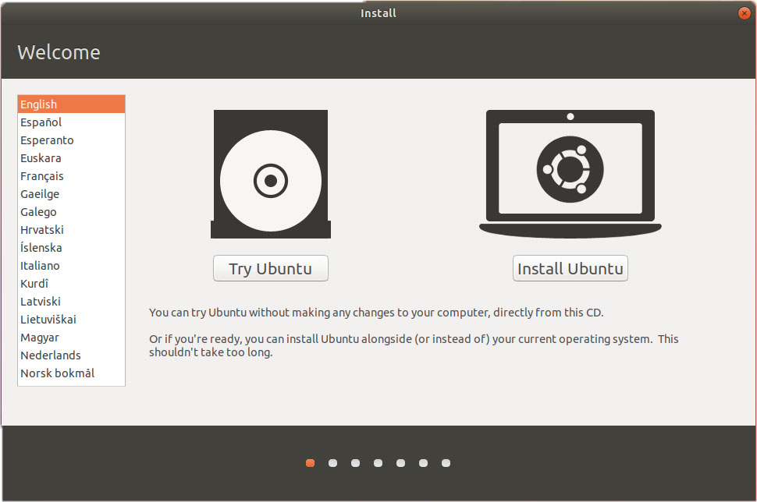

1. **Go through the installation process.**This will differ depending on which distro you are trying to install. These details might include your WiFi network, language, time zone, keyboard layout, etc.
2. **Most distros will allow you to partition your drive or erase it and do a clean install during the installation.**
3. **Reboot your computer when prompted.**If you have more than one OS in your system, you will be taken to a GNU GRUB screen after rebooting. This screen allows you to select which OS you want to boot.

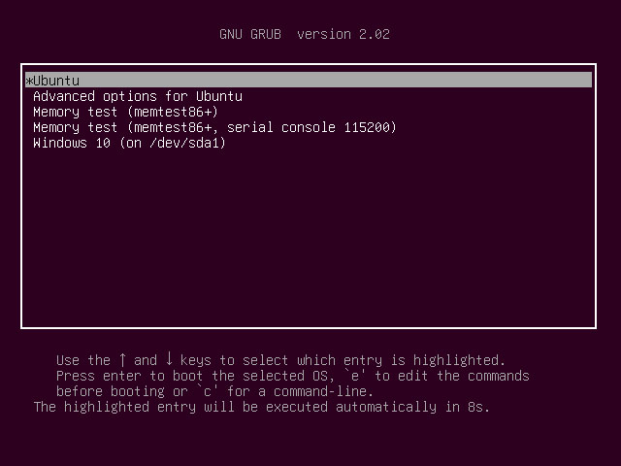

### Installing Linux using USB stick



**Step 1)** Download required files.

**Step 2)** Download Universal USB Installer.

